Module 6
PACKAGES

A package is a collection of classes, interfaces and sub-packages. A sub-package in turns divides into classes, interfaces, sub-sub-packages, etc.
Learning about JAVA is nothing but learning about various packages. By default one predefined package is imported for each and every JAVA program and whose name is java.lang.*.

Whenever we develop any java program, it may contain many number of user defined classes and user defined interfaces. If we are not using any package name to place user defined classes and interfaces, JVM will assume its own package called NONAME package.

In java we have two types of packages they are predefined or built-in or core packages and user or secondary or custom defined packages.

6.1 PREDEFINED PACKAGES

Predefined packages are those which are developed by SUN micro systems and supplied as a part of JDK (Java Development Kit) to simplify the task of java programmer.

NOTE:
Core packages of java starts with java. (For example: java.lang.*) and Advanced packages of java starts with javax. (For example: java.sql.*)

TYPES of predefined packages:
As a part of J2SE we have nine predefined packages which are given in the following table:
Package name | Package description
java.lang.* | This package is used for achieving the language functionalities such as convertion of data from string to fundamental data, displaying the result on to the console, obtaining the garbage collector. This is the package which is by default imported for each and every java program.
java.io.* | This package is used for developing file handling applications, such as, opening the file in read or write mode, reading or writing the data, etc.
java.awt.*  (abstract  windowing toolkit) | This package is used for developing GUI (Graphic Unit Interface) components such as buttons, check boxes, scroll boxes, etc.
java.awt.event.* | Event is the sub package of awt package. This package is used for providing the functionality to GUI components, such as, when button is clicked or when check box is checked, when scroll box is adjusted either vertically or horizontally.
java.applet.* | This package is used for developing browser oriented applications. In other words this package is used for developing distributed programs. An applet is a java program which runs in the context of www or browser.
java.net.* | This package is used for developing client server applications.
java.util.* | This package is used for developing quality or reliable applications in java or J2EE. This package contains various classes and interfaces which improves the performance of J2ME applications. This package is also known as collection framework (collection framework is the standardized mechanism of grouping of similar or different type of objects into single object. This single object is known as collection object).
java.text.* | This package is used for formatting date and time on day to day business operations.
java.lang.reflect.* | Reflect is the sub package of lang package. This package is basically used to study runtime information about the class or interface. Runtime information represents data members of the class or interface, Constructors of the class, types of methods of the class or interface.
java.sql.* | This package is used for retrieving the data from data base and performing various operations on data base.

6.2 USER DEFINED PACKAGES

A user defined package is one which is developed by java programmers to simplify the task of the java programmers to keep set of classes, interfaces and sub packages which are commonly used. Any class or interface is commonly used by many java programmers that class or interface must be placed in packages.

Syntax:
package pack1[.pack2[.pack3……[.packn]…..]];

Here, package is a keyword which is used for creating user defined packages, pack1 represents upper package and pack2 to packn represents sub packages.

For example:
- package p1;
- package p1.p2; statement-2
The statements 1 and 2 are called package statements.

RULE:
Whenever we create user defined package statement as a part of java program, we must use package statement as a first executable statement.

STEPS for developing a PACKAGE:
- Choose the appropriate package name, the package name must be a JAVA valid variable name and we showed ensure the package statement must be first executable statement.
- Choose the appropriate class name or interface name and whose modifier must be public.
- The modifier of Constructors of a class must be public.
- The modifier of the methods of class name or interface name must be public.
- At any point of time we should place either a class or an interface in a package and give the file
name as class name or interface name with extension .java
For example:
// Test.java
package tp;
public class Test
{
public Test()
{
System.out.println ("TEST - DEFAULT CONSTRUCTOR");
}
public void show ()
{
System.out.println ("TEST - SHOW");
}
}

//ITest.java
package tp;
public interface ITest
{
void disp ();
}
Syntax for compiling a package:
javac –d . filename.java

For example:
javac –d . Test.java
Here, -d is an option or switch which gives an indication to JVM saying that go to Test.java program take the package name and that package name is created as directory automatically provides no errors are present in Test.java. When Test.java is not containing any errors we get Test.class file and it will be copied automatically into current directory which is created recently i.e., tp (package name). The above program cannot be executed since it doesn’t contain any main method.

6.3 How to use PACKAGE CLASSES and INTERFACES in another java program:

In order to refer package classes and interfaces in JAVA we have two approaches, they are using import statement and using fully qualified name approach.

6.3.1 Using import statement:

import is a keyword which is used to import either single class or interface or set of classes and interfaces all at once.
Syntax -1:
import pack1 [.pack2 [.………[.packn]]].*;

For example:
import p1.*; ---statement 1
import p1.p2.*; ---statement 2
import p1.p2.p3.*; ---statement 3

When statement 1 is executing we can import or we can access all the classes and interfaces of package p1 only but not its sub packages p2 and p3 classes and interfaces.

When statement 2 is executing we can import as the classes and interfaces of package p2 only but not p1 and p3 classes and interfaces.

When statement 3 is executing we can import as the classes and interfaces of package p3 only but not p1 and p2 classes and interfaces.

Syntax-2:
import pack1 [.pack2 [.…………[.packn]]].class name/interface name;

For example:
import p1.c1; ---statement 4
import p1.p2.c3; ---statement 5

When statement 4 is executing can import c1 class of package p1 only but not other classes and interfaces of p1 package.

When statement 5 is executing can import c3 class of package p2 which is sub package of p1 only but not other classes and interfaces of p1 and p2 packages.

Write a JAVA program which illustrates the usage of package classes?

import tp.Test;
class PackDemo
{
public static void main (String [] args)
{
Test t1=new Test ();
t1.show ();
}
}

When we compile the above program we get the following error “package tp does not exist”. To avoid the above error we must set the classpath as., SET CLASSPATH = %CLASSPATH%;.;

This is the alternate technique for import statement:

6.3.2 Fully qualified approach:

class PackDemo
{
public static void main (String [] args)
{
tp.Test t1=new tp.Test ();
t1.show ();
}
}

NOTE:
- Whenever we develop user defined packages, to use the classes and interfaces of user defined packages in some other program, we must set classpath before there usage.
- When two classes or an interface belongs to the same package and if they want to refer those classes or interfaces need not to be referred by its package name.

For example:
// I1.java
// javac -d . I1.java
package ip;
public interface I1
{
public void f1 ();
public void f2 ();
}

// C01.java
// javac -d . C01.java
package cp;
public abstract class C01 implements ip.I1
{
public void f1 ()
{
System.out.println ("F1 - C01");
}
}

// C02.java
// javac -d . C02.java
package cp;
public class C02 extends C01
{
public void f2 ()
{
System.out.println ("F2 - C02");
}
public void f1 ()
{
super. f1 ();
System.out.println ("F1 - C02 - OVER RIDDEN");
}
}
// PackDemo.java
// javac PackDemo.java
import ip.I1;
class PackDemo
{
public static void main (String [] args)
{
System.out.println ("CP.C02");
cp.C02 o2=new cp.C02 ();
o2.f1 ();
o2.f2 ();
System.out.println ("CP.C01");
cp.C01 o1=new cp.C02 ();
o1.f1 ();
o1.f2 ();
I1 io;
io=o1; //new cp.C02 ();
io.f1 ();
io.f2 ();
}
}

Output:
CP.C02
F1 - C01
F1 - C02 - OVER RIDDEN
F2 - C02
CP.C01
F1 - C01
F1 - C02 - OVER RIDDEN
F2 - C02
F1 - C01
F1 - C02 - OVER RIDDEN
F2 - C02
In order to run the above program we must run with respect to package name.
1 javac –d . PackDemo1.java
2 java mp.PackDemo1 or java mp/PackDemo1 (mp is current working directory)

6.4 ACCESS SPECIFIERS

In order to use the data from one package to another package or within the package, we have to use the concept of access specifiers. In JAVA we have four types of access specifiers. They are private, default(not a keyword), protected and public.

Access specifiers represent the visibility of data or accessibility of data.

Syntax for declaring a variable along with
[Access specifiers] [static] [final] data type v1 [=val1], v2 [=val2] …vn [=valn];

for eg.
public static final int a = 10;
protected int d;
int x;
private int e;
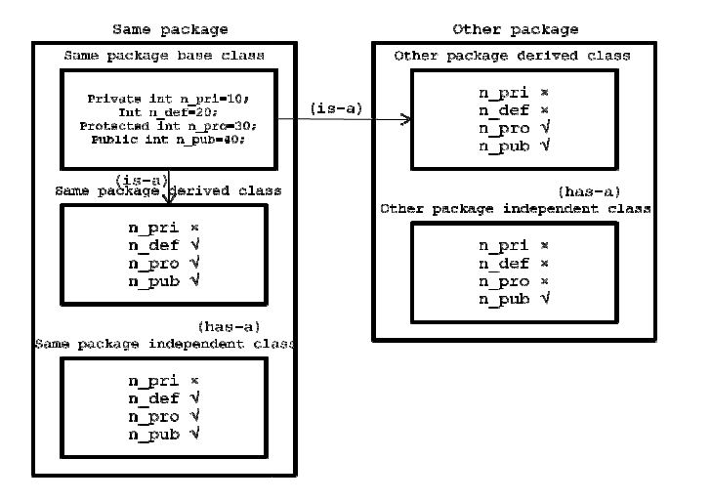
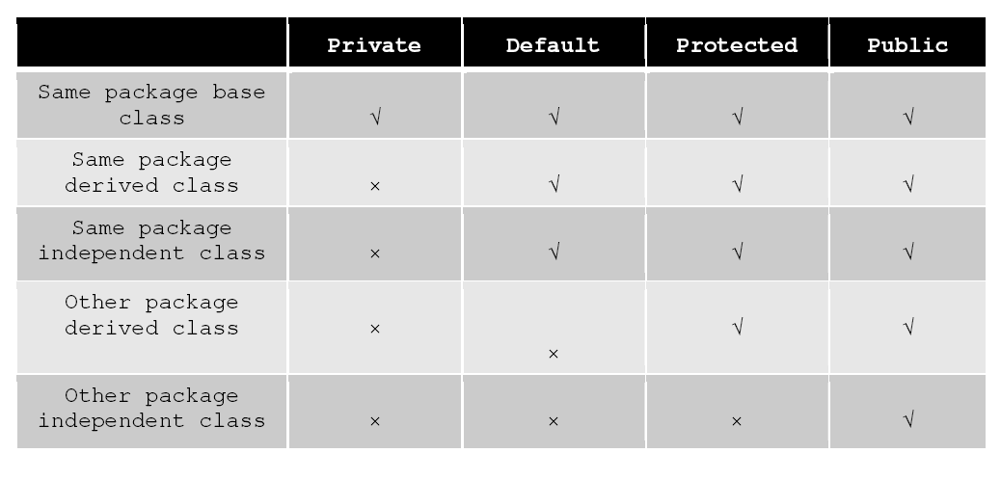
NOTE:
- Private access specifier is also known as native access specifier.
- Default access specifier is also known as package access specifier.
- Protected access specifier is also known as inherited access specifier.
- Public access specifier is also known as universal access specifier.

Program illustrating the use of access specifiers.

// Sbc.java
// javac -d . Sbc.java
package sp;
public class Sbc
{
private int N_PRI=10;
int N_DEF=20;
protected int N_PRO=30;
public int N_PUB=40;
public Sbc()
{
System.out.println ("VALUE OF N_PRIVATE = "+N_PRI);
System.out.println ("VALUE OF N_DEFAULT = "+N_DEF);
System.out.println ("VALUE OF N_PROTECTED = "+N_PRO);
System.out.println ("VALUE OF N_PUBLIC = "+N_PUB);
}
}

// Sdc.java
// javac -d . Sdc.java
package sp;
public class Sdc extends Sbc //(is-a relation & within same package)
{
public Sdc()
{
// System.out.println ("VALUE OF N_PRIVATE = "+N_PRI);
System.out.println ("VALUE OF N_DEFAULT = "+N_DEF);
System.out.println ("VALUE OF N_PROTECTED = "+N_PRO);
System.out.println ("VALUE OF N_PUBLIC = "+N_PUB);
}
}

// Sic.java
// javac -d . Sic.java
package sp;
public class Sic
{
Sbc so=new Sbc(); // (has-a relation & within same package)
public Sic()
{
// System.out.println ("VALUE OF N_PRIVATE = "+so.N_PRI);
System.out.println ("VALUE OF N_DEFAULT = "+so.N_DEF);
System.out.println ("VALUE OF N_PROTECTED = "+so.N_PRO);
System.out.println ("VALUE OF N_PUBLIC = "+so.N_PUB);
}
}

// Odc.java
// javac -d . Odc.java
package op;
public class Odc extends sp.Sbc // (is-a relation & in different package)
{
public Odc ()
{
// System.out.println ("VALUE OF N_PRIVATE = "+N_PRI);
// System.out.println ("VALUE OF N_DEFAULT = "+N_DEF);
System.out.println ("VALUE OF N_PROTECTED = "+N_PRO);
System.out.println ("VALUE OF N_PUBLIC = "+N_PUB);
}
}

// Oic.java
// javac -d . Oic.java
package op;
public class Oic
{
sp.Sbc so=new sp.Sbc (); // (has-a relation & in different package)
public Oic ()
{
// System.out.println ("VALUE OF N_PRIVATE = "+so.N_PRI);
// System.out.println ("VALUE OF N_DEFAULT = "+so.N_DEF);
// System.out.println ("VALUE OF N_PROTECTED = "+so.N_PRO);
System.out.println ("VALUE OF N_PUBLIC = "+so.N_PUB);
}
};

// ASDemo.java
// javac ASDemo.java
import sp.Sbc;
import sp.Sdc;
import sp.Sic;
class ASDemo
{
public static void main (String [] args)
{
// import approach
System.out.println ("WITH RESPECT TO SAME PACKAGE BASE CLASS");
Sbc so1=new Sbc();
System.out.println ("WITH RESPECT TO SAME PACKAGE DERIVED CLASS");
Sdc so2=new Sdc();
System.out.println ("WITH RESPECT TO SAME PACKAGE INDEPENDENT CLASS");
Sic so3=new Sic();
//fully qualified name approach
System.out.println ("WITH RESPECT TO OTHER PACKAGE DERIVED CLASS");
op.Odc oo1=new op.Odc();
System.out.println ("WITH RESPECT TO OTHER PACKAGE INDEPENDENT CLASS");
op.Oic oo2=new op.Oic();
}
}

